COMP4

Norbert Podsadowski

Includes full analysis, design, specific implementation, testing and evaluation of a project management system for Top Builders

2015

Table of Contents

# Analysis

## Backgruond to and identification of problem

Client name: Top Builders  
  
CEO: Peter Podsadowski  
  
Business address: 70 Lucerne Road  
 Thornton Heath  
 London, CR7 7BA

The main end user is my father, Peter, who currently owns a construction company called Top Builders. He conducts various types of construction work, including extensions, furniture fixing, painting & decorating, and more. The company is a small family-based business, and Peter tends to work alone, but sometimes he will hire workers to help him with larger-scale projects. After a few years of good trade, he is looking to expand his business by taking up more projects, hiring more employees and deviating away from a small-scale family business to something more structured. He needs a system to aid him in managing quotes, invoices, employees and his stock of materials in order to ensure a smooth running of the business and decrease the amount of time spent on bureaucracy and administration.

## Observation of the current system

# Physical observation of the current system

Being Peter’s son and living in the same house as him allowed me to observe the working of his current system almost every day. For example, very recently, a new client called him on a Friday enquiring about a job offer; I witnessed the entire conversation and observed how Peter begins his projects through exchanging various details with the client. He arranged an appointment to see the client on the next day (Saturday). I asked to accompany him in order to better understand his work pattern.

We left at 10:00am and made our way to the client’s house. Upon arrival, the client showed us to the kitchen where a whole refurbishment was needed. Peter spoke to him about exactly what needs to be done, which furniture needs to be replaced, the details of any plumbing/electrical work and the estimated time of completion. He used pen and paper to note these things down. At about 3:30pm, we left the client, and said that we would e-mail him with the quote for the required work. *(A quote is a breakdown of the entire project, listing individual jobs involved and estimating potential costs).*

We returned home at about 4:00pm and immediately began working on a quote in Excel. Peter often makes me operate the computer while he simply dictates the jobs, their details and prices as I input them into the spread sheet; this is due to my better IT and English skills. This makes me very knowledgeable in the exact workings of an integral part of the current system, and I have first-hand experience at the somewhat clumsy and time-consuming process of creating customer quotes.

Peter then e-mailed the quote to the client, and after some further negotiations and changes to the quote, work could begin. The details of the job were recorded in a “job book”. Peter needed a helping hand with this kind of project, so he hired an employee (which he has worked with before in the past). He did not need to record the employee on paper, as it was just one employee – but for other projects, where teams of employees are needed, an “employee book” would be used, where working hours and pay rates would be recorded. Both of these record-keeping books are held in the company cabinet at home.

# Interview of company CEO

In order to find out more details about the prospective end user, I carried out a live interview with Peter. This interview aimed to provide the basis for analysis of the current system limitations, setting targets for the new system, planning a feasible solution and ensuring that the finished product meets the requirements of the end user.

**Norbert**: To start us off, what do you currently do for a living?  
**Peter**: I own a building company called Top Builders. I do all kinds of construction work including extensions, kitchen and bathroom fitting, tiling, painting and decorating, etc.  
  
**Norbert**: Do you work on your own?  
**Peter**: Mostly, yes. I am self-employed under the Top Builders name and the company is entirely run by me. However, for some bigger jobs, I tend to hire a couple of workers to help me. I pay them a working wage but act as the project manager, while still of course working with them on-site.

**Norbert**: How do you co-ordinate your workers, keep track of how many hours they have worked, etc.?  
**Peter**: Well, I guess I just keep it in my head, or write it down in a little job book that I have. I haven’t used this much, but I expect that to change once I start hiring more workers. At the moment, I hand them the money after a week of work and just tell them the days when they should come in and where we’re going.

**Norbert**: That sounds a bit cumbersome?  
**Peter**: It is, but I don’t hire that much workers for it to be too much of an issue at the moment. However, if I carry on getting large-scale projects like I have been recently, it could get very disorganised.

**Norbert**: What about the details of all the jobs you need to complete?  
**Peter**: I record those inside a large “job book”, which records the details of every client, the jobs they need us to do, things like that. I use this information to later produce a quote for the client.

**Norbert**: Do you ever advertise, or is your business quite small?  
**Peter**: I give out business cards to any potential clients which may require my services. I am advertised on Yell and have a van with my business logo and contact details on it. I also had a simple website which listed all my services, but found it not useful enough in bringing in new clients for the price I was paying, so I got rid of it.  
  
**Norbert**: How do you find your work, and then how do you proceed to complete it?  
**Peter**: I receive work, very often through recommendation, from a potential client and immediately arrange a meeting to inspect the premises and discuss the details. Using this information I then produce a quote listing all of the specific jobs that need to be done, and the total cost. I then present this quote back to the client, discuss any amendments, and begin work immediately. Once complete, I hand the client an invoice, which is basically just the same as a quote, but with slight amendments to reflect the exact work that was completed.

**Norbert**: Could you tell me more about what you include in your quotes?  
**Peter**: All of my quotes tend to differ a lot due to the fact that I make them manually in Microsoft Excel. Usually I will have a table of 5-10 jobs for the project, with different materials listed for every job. I will then have a price for every job, and sometimes break this price up to indicate labour and material costs. I will also have a total at the bottom. I like to include my company logo and the name and address of the client, although sometimes forget to do this.

**Norbert**: And how long do these quotes take to produce?  
**Peter**: Well, I am nearly 50 years old, and although I don’t consider myself completely backwards in terms of technology, messing around in Excel can sometimes take me up to 3 hours to complete one quote. Most of the time I just ask you to do it, as you’re much quicker.

**Norbert**: What would you like the new system to do for you?  
**Peter**: I mainly want something easier than Excel produce my quotes for me quickly and efficiently. I want to be able to quickly launch an application, fill in some jobs details and figures and have it printed off and the client e-mailed within minutes. Of course the format still needs to be Excel, just not made using Excel, if that makes sense, as I find most clients are able to open such a format, and it can be made to look nice.

**Norbert**: Is that all you need the system to do, or do you have anything else in mind?  
**Peter**: Well, I’m open to suggestions. Anything to make my life easier.

**Norbert**: Well, what about the future? Where do you see your business going?  
**Peter**: Right now, everything is going pretty well and I would love to turn this into a more of a structured enterprise rather than a small family business. I will definitely be pursuing some higher forms of advertising in the future so that I can get a much larger volume of clients. Of course, this will mean hiring a proper team of employees. A proper website will eventually become a must.

**Norbert**: What would this website contain?  
**Peter**: A description of all the services I provide, a gallery, my contact details. It would also be nice if clients could request a quote online which I could somehow see and complete.

**Norbert**: That could definitely be something I could include in the system, allowing you to respond to quote requests submitted online. Would that be useful?  
**Peter**: Absolutely! It would be incredibly convenient to direct potential clients onto the future website and allow them to describe their problem without me having to take the time out to see them or call them.

**Norbert**: How do you currently get all of the materials you need to complete a project?  
**Peter**: After producing the final quote I take a trip to any builders’ warehouse such as Selco and pick out all the things I will need. This sometimes takes more than one trip and is quite tedious to do, but I have no other choice. If the business was large enough, I would probably store a stock of materials somewhere and pick them out from there.

**Norbert**: Surely you would need something to manage that stock electronically?  
**Peter**: I would indeed.

**Norbert**: That’s something worth looking into for the new system. Finally, do you have any final thoughts on how you would like your new system to function?  
**Peter**: I just want something that works well, is fast and isn’t overly complicated. Initially I just wanted a simple quote maker, but now that I think about it, the expansion of my business may come quite soon and I will most likely require other tools to help me. For example, that stock of materials manager you mentioned sounds like it could be very useful.

**Norbert**: I will definitely aim to produce something that satisfies your long-term requirements. Thanks for your time; it was very helpful in determining exactly what you need.  
**Peter**: No problem. I will be looking forward to closely watching over the design of this new system.

*Interview was conducted in Polish and later translated and adjusted for easier understanding.*

# Document analysis

  
In this section, I will analyse a typical Top Builders quote in order to increase my understanding of the needs of the end user. These are real, actual quotes of previous projects which the company has completed.

The quotes appear to differ in layout for every project. The proposed system should aim to avoid this and produce standardised and consistent quotes for every project. However, some projects will require quotes to occasionally differ. The proposed system needs to cater for this and allow toggling of various additional columns as necessary, such as “job description”, “material cost”, etc.

Top Builders company logo.

*Note: The word “quote” is interchangeable with “invoice”, as both are exactly the same in layout, and will be treated as the same thing in the proposed system.*

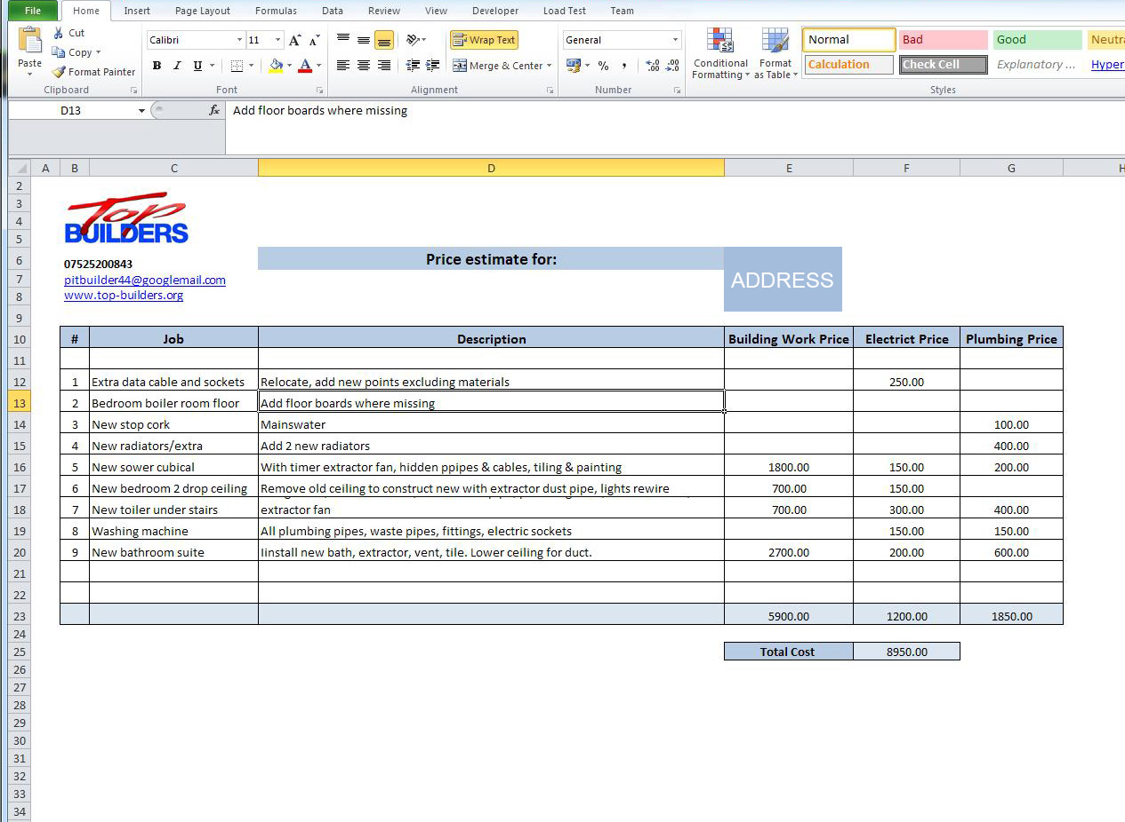

Company details need to be visible for every quote.

Every invoice displays the address of the project. *(Hidden for data protection reasons)*

Occasionally, jobs will require additional descriptions.

All quotes need to have a breakdown of all the individual jobs for every project.

## D:\Dev\Projects\BuildersCentral\BuildersCentral\COMP4 Project - Norbert Podsadowski\invoice2.jpg

Some quotes will display material and labour costs in one value. Other quotes may break this down to show material costs, labour costs and even time taken per job.

These columns and various settings for the customization of quotes should be easy to toggle in the quote creator of the proposed system.

A total for each column should be displayed at the bottom of a quote.

The biggest projects may need a categorical break-down of jobs, as shown on the left. The jobs for this project have been sorted in various groups. This capability needs to exist in the proposed system.

## D:\Dev\Projects\BuildersCentral\BuildersCentral\COMP4 Project - Norbert Podsadowski\invoice3.jpg

Occasionally, a “note” or final project description will be included at the end of a quote.

The table of materials in the database should store price per unit, amount in stock and type of unit (length, width, units, etc)

The following is an invoice from Selco Warehouse, one of Top Builders material suppliers. This is an example of materials that will have to be stored in the system.  
  
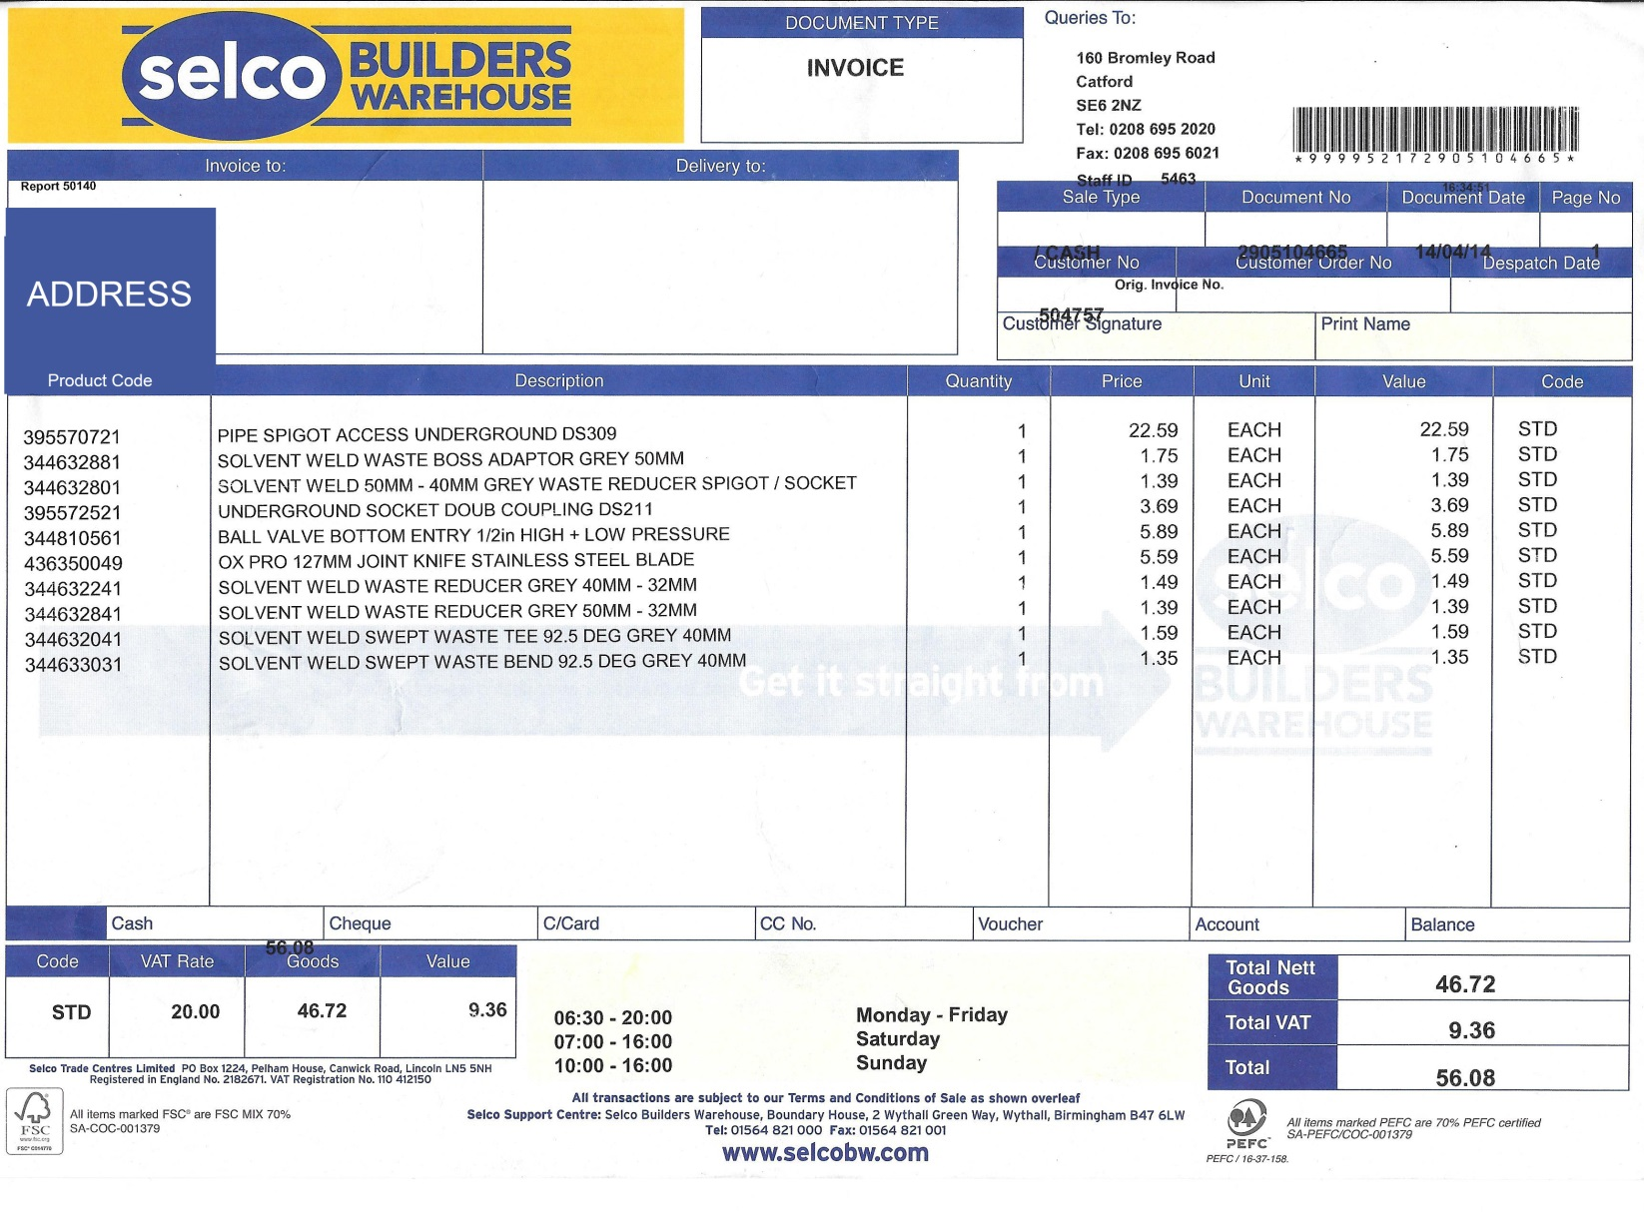

# 

# End user questionnaire

Although the interview and documents provided by Peter have provided me with a lot of information, this questionnaire was also given for him to complete. It deals with more quantitative information which will clear up concerns regarding data volume and other details which weren’t discussed previously.

1. How many hours per week do you spend on completing tasks related to the running of your business (creating invoices, speaking with customers, etc)?

*6-8*

*3-5*

*< 3*

*> 11*

*9-11*

1. How many of these hours are spent on tasks which require you to use a computer?

*6-8*

*3-5*

*< 3*

*> 11*

*9-11*

1. How many projects do you complete during an average quarter (3-month period)?

*> 11*

*9-11*

*6-8*

*3-5*

*< 3*

1. How many projects do you expect to complete during an average quarter in about 2 years?

*9-11*

*6-8*

*3-5*

*< 3*

*> 11*

1. How many projects does an average client provide after initially meeting them?

*3*

*2*

*1*

*> 4*

*4*

1. How many different types of materials does an average project require?

*< 4*

*> 21*

*16-21*

*10-15*

*4-9*

1. How many employees do you currently hire to accommodate for all your projects?

*2-3*

*1*

*> 7*

*6-7*

*4-5*

1. How many employees are you expecting to in the next 2 years?

*6-7*

*4-5*

*2-3*

*1*

*> 7*

1. How many individual jobs does an average project require?

*6-10*

*< 5*

*> 20*

*16-20*

*11-15*

1. How many times per week on average do you receive calls from potential clients?

*2*

*< 2*

*> 4*

*4*

*3*

## Description of the current system

After primary observation of Peter’s current system, document analysis, the interview and completion of the questionnaire, Peter’s current system may be summarised as follows:

1. Find a client, either through recommendation, advertising or otherwise
2. Consult with the client, assess the construction work to be completed
   1. Peter records a new client’s details and the job details in the company job book
3. Produce a quote (price estimate) of the work and present this to the client
   1. The quote should include a breakdown of all the jobs to be done for the whole construction project, the details of each job, the materials required and the prices for each individual job
   2. This is currently done manually, using an Excel spreadsheet
4. Further consultation with the client based around the produced quote
5. Employees are hired for the project, and assigned concrete tasks and working hours
6. Work then begins
7. After the construction project is complete, the client is handed an invoice which represents the actual work done, materials purchased, and overall cost
8. Employees are paid

## Identification of prospective users

The main user of the system will be Peter, as he is the CEO of the company and deals with all client-business communications, like initial consultation or quote creation. He is also responsible for managing employees, and in the future, when his company expands, there is a possibility of him hiring higher ranked employees to manage workers across different projects for him. Another prospective user is an employee of the company, who should be able to use the system to get information such as tasks assigned during a project, hours of work and wage rate. An easy way to contact the responsible supervisor, such as a manager or Peter himself, should also be provided in the form of e-mail.

Summary of users:

1. Peter (company CEO)
2. Any managers/supervisors
3. Regular employees

## Limitations of the current system

Based on the conducted interview and outline of the system, the following limitations can be concluded:

* Creation of invoices is cumbersome and requires tinkering with Excel spread sheets
* Invoices/quotes are not standardised, i.e. the layout and look of each quote differs
* Employees are managed on paper (sometimes not even formally recorded)
* No way of potential clients to request quotes without meeting Peter
* No way of organising tasks between employees, leading to disorganisation
* Materials must be found and purchased manually, and are not recorded on paper
* No way for employees to discuss current assignments out of the area of work

## Identification of user needs and acceptable limitations

Peter needs a system which solves the above limitations. The list of user needs and acceptable limitations may be summarised as follows:

* Manages any amount of current projects
* Automates the creation of quotes/invoices, with the capability of exporting to Excel
* Allows customers to request a quote using an interlinked online form. These “quote requests” will be placed in a queue and completed in the order received. The client will be e-mailed with the completed quote
* Provides an employee management system, with capability of assigning concrete tasks and different pay rates
* Provides an employee login system which lists assigned tasks, pay rate and easy contact with project manager through e-mail
* Manages the stock of materials, keeping track of the different types of material in stock and potential shortages based on the current projects to be completed
* Produces stock reports which list material lists/deficiencies
* Allows the exchange of messages between existing employeees

These are the main things which the new system should accomplish. Some other, less critical features, but ones which could be implemented as an extension to the completed system, are as follows:

* Allows new materials to be found through various online stores, through a search system which filters for best prices
* Allows account customisation through an adequate list of settings/preferences to suit user needs

## Data sources and destinations

|  |  |  |
| --- | --- | --- |
| Data | Source | Destination |
| Client details | Client (e-mail, phone, word of mouth) | Company job book |
| Job descriptions | Discussion between Peter and client | Company job book |
| Job costs | Peter | Client, company job book |
| Job materials | Peter | Client, company job book |
| Employee full name | Employee | Peter |
| Employee address | Employee | Peter |
| Employee contact number | Employee | Peter |
| Company business email | Peter | Client |

## 

## Data volumes

Data volumes will be analysed based on the information provided in the questionnaire and interview.

Top Builders works on about 3-5 projects during an average 3-month period. However, the business may soon expand, and Peter expects this to this number to increase to approximately 9-11 employees in about 2 years. It is therefore important to create a scalable system which is capable of managing the higher data volumes in the future. Taking 10 projects as an average volume of projects per quarter, this requires about 300 different individual jobs if the average project has 10 jobs. For these 10 projects, Peter indicated that he will hire more than 7 employees which will all need an account in the system. Peter indicated about 6-10 different types of materials are used for an average project, so 10 projects could mean about 60-100 different material requirement entries in the database. This doesn’t take into account the fact that a separate storage is needed for the entire material stock which could exceed about different 50 material types. Regarding quote requests, Top Builders receives less than 2 calls per week from a new customer. Therefore we can assume to receive about 1 online quote request per week, and this is likely to be higher as the future website increases its ranking on search engines and upon company expansion.

The database system to be used in this project will be MySQL. This is an industry-standard database, capable of executing queries at a very fast speed, and able to handle millions of rows of data. It is unlikely that the data stored in this project management system will ever exceed the capabilities or storage requirements of MySQL.

*Note: this project will not focus on creating an online website for Top Builders. The aim is to create a project management system, and the online quote request element will be a simple form designed to be “plugged in” to the (potential) future website, which I will not be creating. However, the database will be hosted online, to allow data to be stored in just one remote location and make it accessible from any machine. This is important, as employees will be logging into the system from their personal computers at home, and this would be impractical (or even impossible) without an online-hosted DB.*

## Analysis data dictionary

|  |  |  |
| --- | --- | --- |
| Field name | Data type | Details |
| Client full name | String | First and last name of a client |
| Project address | String | Street name, town, city and postcode |
| Project contact number | Integer | Preferably a mobile number on which the client of the project can always be reached |
| Project e-mail address | String | The main medium of contact between the client and the business, used to send quotes and other documents like construction plans, as well as general updates or enquires while the job is being completed |
| Job descriptions | String | Up to 150 words per job of a clear outline of what has to be done, e.g. “Fix new living room furniture” |
| Job costs | Real | The cost of an individual job |
| Job materials | String | The materials required to complete a particular job, e.g. for a kitchen refurbishment, a new counter top may be needed |
| Employee full name | String | First and last name of an employee |
| Employee address | String | Street name, town, city and postcode |
| Employee contact number | Integer | Preferably a mobile number on which the employee can always be reached |
| Employee e-mail address | String | Must be a valid e-mail address which is often checked, as it is used for a lot of business communications with the employee |
| Employee wage rate | Real | An hourly wage rate |
| Employee work hours | String | A specification of the concrete days on which the employee is expected to work as well as exact start/end times of shifts |

## 

## Data flow diagrams

The following are data flow diagrams, provided for both the existing and proposed systems, showing an overview of the context (level 0) as well as a detailed breakdown (level 1) of each system.

# Level 0 existing system DFD

# N:\git\BuildersCentral\BuildersCentral\COMP4 Project - Norbert Podsadowski\Level 0 DFD - Existing System.jpg **Level 1 existing system DFD**

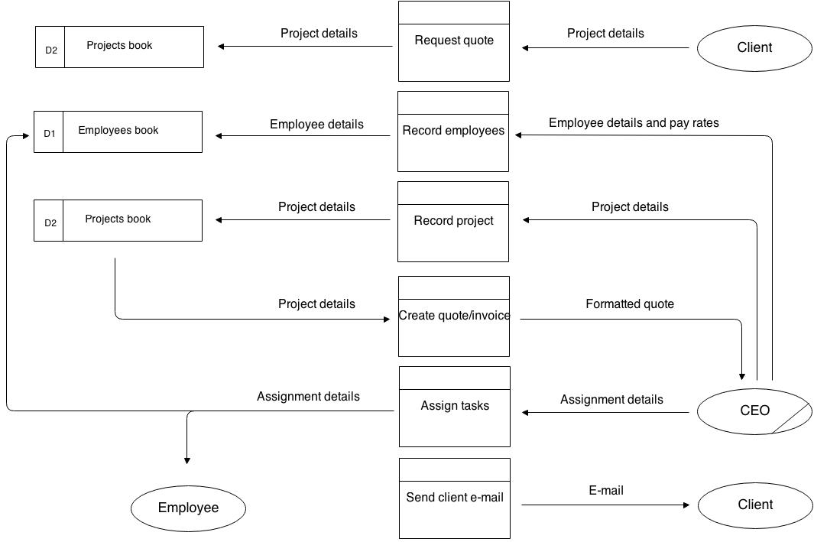

Level 0 proposed system DFD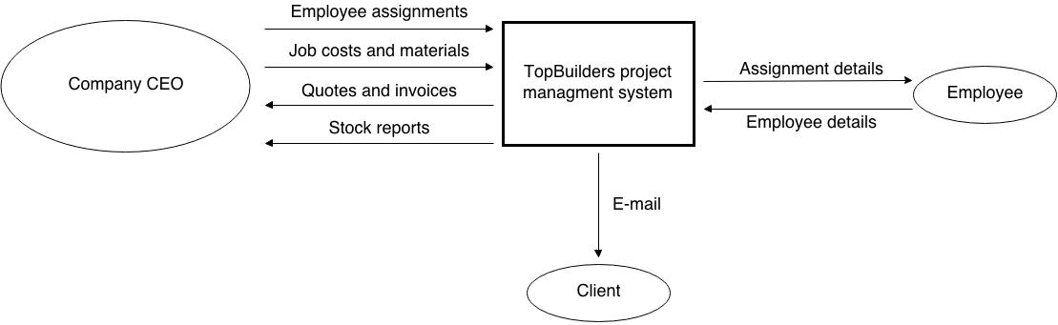

Level 1 Proposed System DFD

Level 1 proposed system DFD 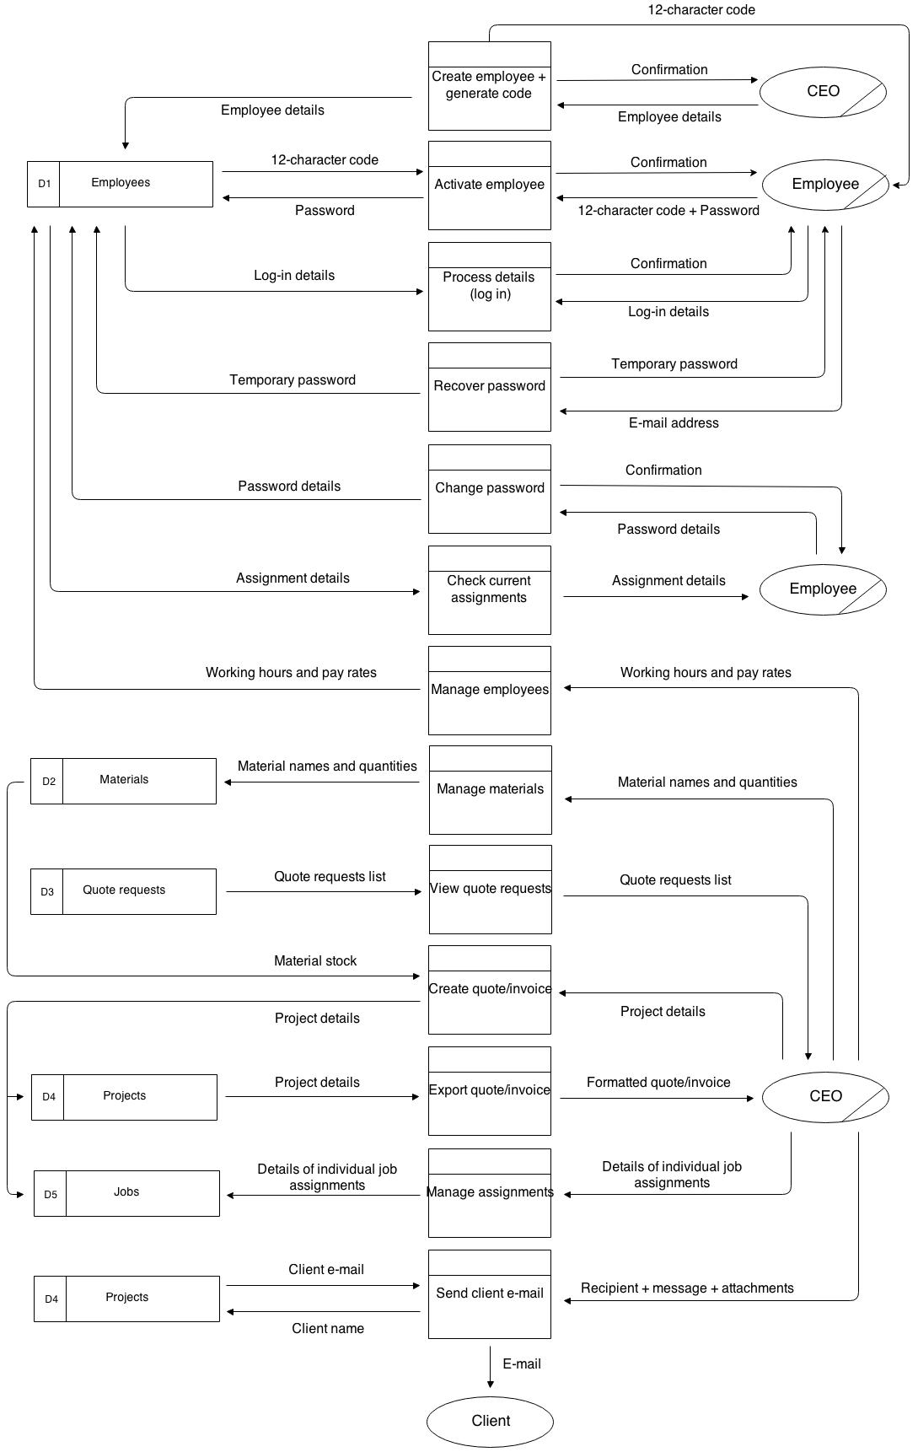

Entity relationship diagram

The following ERD shows the planned database tables for the proposed system, displays their relationships to other tables and lists their individual fields. It is important to not confuse a “project” with a “job”. As an example, a kitchen refurbishment for a client is a *project* – the individual jobs belonging to this project could therefore be “paint walls” and “place tiles”, both with individual labour and material costs.

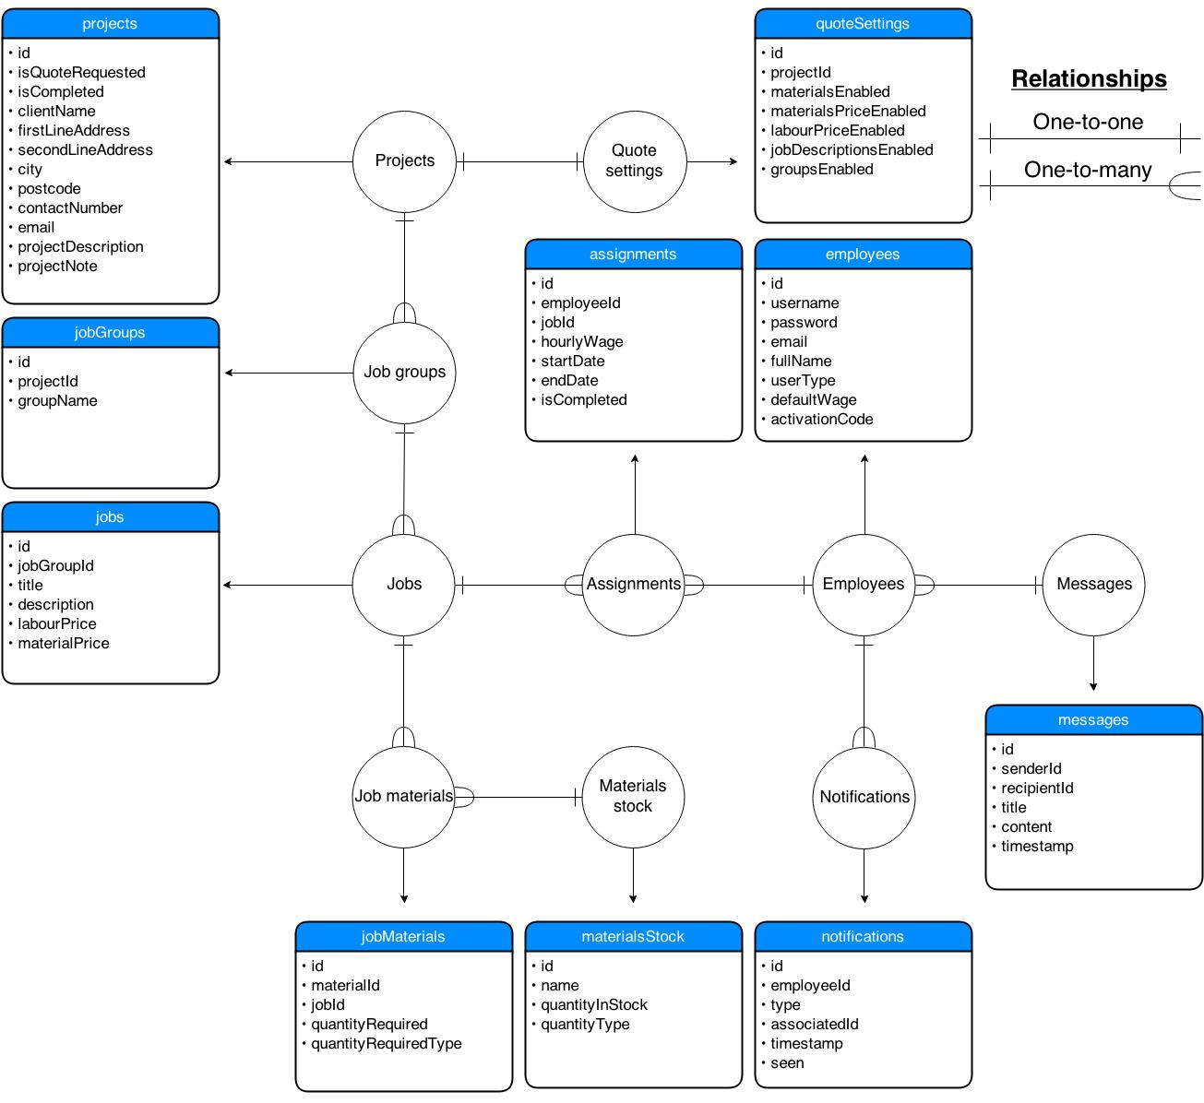

Notes regarding DB tables:

* Table *quoteSettings*: used to store Boolean values representing whether various columns in the quote should be displayed. The most simple, “generic” quote (with no additional settings enabled) will simply store a list of job titles and their corresponding prices. Peter may wish to enable other columns to suit the needs of a given project – for example, he might enable the materials column and list the materials required for each job. He could break this down further by enabling the materials price column for every job, or even the labour price column to distinguish the prices for both. He can also decide to group the jobs, as seen in the quote analysed earlier. If more detail is needed than just a job title, individual job descriptions may be also enabled.
* Field *isQuoteRequested* in table *projects*: used to indicate whether the given project is a quote request made online, or simply a new project created directly by Peter. This will be used to create a list of quote requests, distinct from a list of actual accepted projects. A quote request will supply most of the information that a project requires, and it is up to Peter to fill in individual jobs, costs and notes.
* If field *groupsEnabled* in table *quoteSettings* is *FALSE*, then all jobs relating to that project will not have a jobGroupId.
* Field *materialPrice* in table *jobs*: only used if *materialsPriceColEnabled* is *TRUE.* The same can be said for the *labourPrice* and *labourPriceColEnabled* fields. If no listing of labour or materials is made (both columns disabled), and there is simply 1 type of cost per job, then this cost is stored in the *labourCost* field. If both *materialsPriceColEnabled* and *labourPriceEnabled* are *TRUE,* then the total job cost will be calculated as *materialCost* + *labourCost*.

Object analysis diagrams

TODO

System objectives

General objectives

1. Allow customized quote/invoice creation and modification facility
2. Keep track of hired employees using a login system
3. Keep track of stored materials and their deficiencies, and generate reports based on these
4. Provide an employee assignment facility
5. Provide an employee messaging facility
6. Allow easy response to quote requests made by potential clients online

Specific objectives

1. Store user accounts for every employee, including their user type and personal details
2. Store projects, their corresponding jobs, groups, descriptions, material requirements and Store client details
3. Store stock of materials and quantities of each type
4. Store assignments of jobs across multiple employees, start and end dates, wages and completion status
5. Store messages sent between employees
6. Store any relevant user-specific settings or preferences
7. Process login details for employees, including password encryption
8. Process password change and recovery details
9. Process labour and material costs for quotes
10. Process material requirements compared with material stocks, and lists of lacking materials to be purchased
11. Process weekly wages based on completed assignments
12. Process estimated times of completion of projects based on assigned tasks and end dates
13. Process queue of quote requests, in chronological order
14. Process e-mails to be sent to clients and employees
15. Process stock reports
16. Process addition and deletion of quotes, employees, materials and quote requests
17. Process sending of messages
18. Process addresses and embed Google Maps imagery where appropriate
19. Process notifications of new messages, quote requests and assignments on employee home pages
20. Output formatted quotes in an Excel spread sheet, created programmatically, including content and styling
21. Output queue of quote requests received, displayed in a gallery-style with pictures (if attached)
22. Output messages received by other employees
23. Output stock reports
24. Output assigned tasks, including a list of co-workers with the same assignments
25. Output client emails

Feasibility of potential solutions

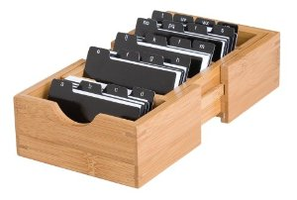Improve existing system

Storing clients and employees in designated, alphabetical files would greatly improve organisation, and prevent loss of data. Top Builders could invest in an index card organiser, allowing Peter to avoid memorising vital information (such as about his employees) which could be a risk to the business, especially after expansion. This improvement in organisation would make every entity in the system represented by a single expandable file, and allow quick searching for any given record.

Another, perhaps stronger improvement would be to use Peter’s familiarity with Excel and create a spreadsheet for his currently employed workers, their pay rates and contact information. This would allow quicker input, easier searching and a much lower risk of damage (as paper could be torn and lost) of data. Once the spreadsheet is created, its structure does require often changing, and provides a cost-effective way of greatly improving organisation. This spread sheet also be adapted to store the current stock of materials, although the effectiveness of this is questionable.

* Advantages
  + Very little associated cost
  + Can be accomplished very quickly
  + Reliability – Excel is a well-established and mature software package, unlike a potential bespoke solution
* Disadvantages
  + Storing materials on spreadsheets can be unreliable – constant modification of hundreds, potentially thousands of columns can lead to human error
  + All spread sheet and written solutions are subject to human error in both input (e.g. inputting a wrong value on a spreadsheet) and processing (e.g. later using a calculator and mistyping a digit).
  + Does not allow for any advanced processing (automatic e-mails, stock reports, employee messaging and assignment)
  + Difficult to scale – when the company gets large, having a lot records stored on paper greatly increases retrieval time, and potential loss/damage

Purchase special-purpose software

Various special-purpose software packages currently exist on the market. Top Builders could invest into one or more packages which could satisfy their user needs. A project management system, together with an employee tracking feature as well as a material stocking system would therefore be needed.

1. The Project Builder guides you through creation of the project
2. Create, edit or delete tasks and build phases with ease
3. Add sub-tasks to tasks and link related activities
4. Assign resources to tasks, sub-tasks and build phases
5. Add "Baselines" to track any amends to the project
6. Show planned vs actual progress on the job
7. Monitor allocation of resources, cash flow and revenue
8. Customise the look and feel of your charts
9. Export dates into iCalendar format to put into MS Outlook, Google Calendar etc
10. Print your chart, export to MS Excel or email to clients

One of these packages is called ProjectXpert by HBXL Building Software. It’s main feautures are quote from the website on the right.

* Advantages
  + Does not require a waiting period – the package can be bought and used instantly
  + Special-purpose software has been thoroughly bug-tested and matured over years, increasing their reliability
  + Often has a more complex feature set (can be a disadvantage, see below)
* Disadvantages
  + A single package does not meet all of the end user’s requirements
  + Multiple packages need to be bought which increases the overall cost
  + ProjectXpert alone costs £500 + VAT, and about 3 different packages are needed, adding a very heavy cost to a small family business with little capital
  + Most ready-made software will be bloated with features, most of which unnecessary to the end user
  + Due to these excessive lists of features, a non-technical CEO like Peter could have a hard time using the system, or take a very long time to adjust. Easy accessibility and a very friendly user interface are major requirements of the end user.
  + Many of these systems will not provide an remote, online database which multiple clients can connect to – rather, they are single packaged designed to be installed on one machine.

Purchase a system from a bespoke software development company

A bespoke system for Top Builders could be created, which aims to meet all of the end user’s requirements. Top Builders could hire a professional team of bespoke developers which would assess Peter’s needs again and design and implement a feasible solution. Later, this solution could be maintained, improved and tested – these services may come at an additional cost.

* Advantages
  + Can be made to fit the user needs very closely
  + The CEO can have a very large influence into the design of the software, personalising it to his needs
* Disadvantages
  + Very expensive
  + Some bespoke firms may go out of business or stop offering their services – leaving the system unmaintained in the long term
  + Extra charges for support, maintainance and features

Create a bespoke system internally

This would involve the same process as a software development company would go through. However, the system would be created entirely by myself.

* Advantages
  + Being Peter’s son, I will be able to customize the software more precisely to the user’s needs that in any of the other 3 possible solutions
  + No (or very minimal) costs involved
  + Can be supported and maintained in the long-term, as the software creator will always be around and capable of fixing bugs, adding features
* Disadvantages
  + Could take a significant amount of time to complete, given a 1 person team
  + Technical difficulties – although this would not be my first major programming project, I could sometimes run into problems which a professional bespoke software company would be able to resolve in a shorter amount of time
  + Depending on programming langage/technologies used, could require learning of various new tools

Justification of chosen solution

Improving the current system simply does not satisfy enough needs of the end user. A major system requirement is the ability to easily created standardised, customisable quotes as well a managing stocks and quote requests. Without a computerised system, this is not possible. Furthermore, scalability is a major requirement of the new system – keeping all records on paper makes this very difficult for reasons outlined earlier.

While combinations of special-purpose software is likely to exist which meet the needs of the users, it is unlikely that there is a single package which satisfies all the precise needs listed. A combination of packages would therefore be needed to be purchased, and these packages can be very expensive. This is a major problem for a small firm like Top Builders which does not have a lot of operating capital.

Bespoke software allows the precise needs of the end user to be satisfied. It eliminates the need to deal with bloated, uneeded features which can confuse a non-technical audience (Peter and his employees). Peter wants a highly custoimized system and would like to play a major part in infuencing its design, and this would be imossible without a bespoke system.

An internally created bespoke system is the most advantageous way of implementing the proposed system. It would be very cost-effective, as no professional software teams are hired, which can cost even more than a special-purpose software pakacge “off the shelf”. A key advantage is the fact that the system is going to be created by the son of the main end user – through this, improvement and maintainane can be easily performed in the future, while a bespoke team would likely charge for such services. Although this solution would take the longest time to implement, this is not a major disadvantage as the company is only starting to expand – the current system is feasible for the current size of Top Builders, and a new system is not required right away. I have conducted various programming projects before, which were similar in size to the proposed system, and therefore I would be taking up this task with a good technical foundation.

In conclusion, it is decided that the best way for Top Builders to achieve a system capable of meeting their needs and objectives is an internally created piece of specialist software.

Design

**Overall system design**

**Description of modular structure of system**

Diagram

**Definition of data requirements (Design Data Dictionary)**

|  |  |  |  |  |  |  |  |
| --- | --- | --- | --- | --- | --- | --- | --- |
| Table name: projects | | | | | | | |
| Field name | Data type | Required | Validation type | Validation rules/details | Error message | Sample data | Description and key fields |
| id | Int | Yes | Uniqueness check, presence check | Is unique, is present | No need, generated | 3 | Primary key |
| isQuoteRequested | Bool | Yes | Presence check | Is present | No need, generated | True | Specifies whether this project was requested through the online form |
| isCompleted | Bool | Yes | Presence check | Is present | No need, generated | False | Specifies whether this project has been completed |
| clientName | String | No | Length check | Is 0-40 characters long | Please enter a shorter client name | John Smith | The full name of the person buying the services of Top Builders |
| firstLineAddress | String | No | Length check | - | - | 63 Green Road | The 1st line of the address where the project is to be completed |
| secondLineAddress | String | No | Length check | - | - | Thornton Heath | As above – 2nd line |
| city | String | No | Length check | - | - | London | The city of the address |
| postcode | String | No | Length check | Is 5-7 chars, irrelevant of spaces | Please enter a valid postcode | SW19 8HJ | The postcode of the address |
| contactNumber | String | No | Format check (regular expression) | Contains exactly 11 numbers | Please enter a valid contact number | 07545892134 | The contact number to be used when attempting to communicate with the client |
| email | String | No | Format check (regular expression) | Starts with any alphanumeric string, followed by ‘@’, followed by a similar string. Strings before and after the ‘@’ sign cannot start or end with a ‘.’ | Please enter a valid email address | email@domain.something.com | An alternative to the contact number |
| projectDescription | String | No | - | - | - | An entire bathroom refurbishment – plastering, tiling and painting, including the fixing of furniture | A description of the project – initially entered by the client (if requested online) and later modified by managers, if necessary. Not displayed on the quote – used to simply specify project objectives for the managers/employees |
| projectNote | String | No | - | - | - | Note: the total cost does not include the service charges of the asbestos company | A note entered by the managers, later to be displayed on the quote (unlike the description). Used to provide extra information about the quote or any other qualitative data |

|  |  |  |  |  |  |  |  |
| --- | --- | --- | --- | --- | --- | --- | --- |
| Table name: quoteSettings | | | | | | | |
| Field name | Data type | Required | Validation type | Validation rules/details | Error message | Sample data | Description and key fields |
| id | Int | Yes | Uniqueness check, presence check | Is unique, is present | No need, generated | 3 | Primary key |
| projectId | Int | Yes | Uniqueness check, presence check | Is unique, is present | No need, generated | 5 | Foreign key – projects table. Indicates the project associated with these settings. Must be unique as this is a one-to-one relationship (every project has only one set of settings) |
| materialsEnabled | Bool | Yes | Presence check | Is present | No need, controlled by tick box | True | Specifies whether the quote associated with these settings includes a materials column |
| materialsPriceEnabled | Bool | Yes | As above | As above | As above | True | As above, but toggles the materials price column |
| labourPriceEnabled | Bool | Yes | As above | As above | As above | True | As above, but toggles the labour price column |
| jobDescriptionsEnabled | Bool | Yes | As above | As above | As above | True | As above, but toggles the description boxes for individual jobs |
| groupsEnabled | Bool | Yes | As above | As above | As above | True | Specifies whether the quote associated with these settings allows for various job groups to be created. If “false”, then no job groups will be allowed with this quote, and all jobs will be stored with a groupId of 0 |

|  |  |  |  |  |  |  |  |
| --- | --- | --- | --- | --- | --- | --- | --- |
| Table name: jobGroups | | | | | | | |
| Field name | Data type | Required | Validation type | Validation rules/details | Error message | Sample data | Description and key fields |
| id | Int | Yes | Uniqueness check, presence check | Is unique, is present | No need, generated | 3 | Primary key |
| projectId | Int | Yes | Presence check | Is present | No need, generated | 5 | Foreign key – projects table. Indicates the project associated with this group of jobs |
| groupName | String | Yes | Presence check | Is present | Please enter a group name | Bathroom | Specifies the name of the group |

|  |  |  |  |  |  |  |  |
| --- | --- | --- | --- | --- | --- | --- | --- |
| Table name: jobs | | | | | | | |
| Field name | Data type | Required | Validation type | Validation rules/details | Error message | Sample data | Description and key fields |
| id | Int | Yes | Uniqueness check, presence check | Is unique, is present | No need, generated | 3 | Primary key |
| jobGroupId | Int | Yes | Presence check | Is present | No need, generated | 5 | Foreign key – jobGroups table. Indicates the group which this job is associated with. Has the value of 0 if “groupsenabled” is false (in the quotesettings table), in which case there are no groups |
| title | String | No | - | - | - | Strip out old tiles | A short title of what the job entails |
| description | String | No | - | - | - | May require filler | A more detailed description of the job, if necessary |
| labourPrice | Double | No | Type check | Is a numerical value | Please enter a valid labour price for job “[title]” | 120.50 | The cost of Top Builders labour to the client. If the labour price column and the material price column for this quote are disabled (as specified in the quoteSettings table), then this field is used as a combined “total” cost for this job |
| materialPrice | Double | No | Type check | Is a numerical value | Please enter a valid material price for “[title]” | 300 | The cost of materials to the client. If the material price column is disabled, this field is left blank |

|  |  |  |  |  |  |  |  |
| --- | --- | --- | --- | --- | --- | --- | --- |
| Table name: employees | | | | | | | |
| Field name | Data type | Required | Validation type | Validation rules/details | Error message | Sample data | Description and key fields |
| id | Int | Yes | Uniqueness check, presence check | Is unique, is present | No need, generated | 3 | Primary key |
| username | String | Yes | Presence check, format check (regular expression), length check | Is present, is alphanumeric with the addition of “_”, is 4-15 characters in length | Please enter a desired username for this employee. Usernames must be 4-15 characters long, contain only alphanumeric characters and the underscore. | npods | The user name used to log in to the system. Users will be created by Top Builders managers and therefore inputted into a form, so need to be validated |
| password | String | Yes | Presence check, format check (regular expression), length check | Is present, is in the range of 6-20 characters, contains at least one capital letter and at least one number. Must be alphanumeric with the addition of “_” | Please enter a valid password. Passwords must be 6-20 characters in length, contain only alphanumeric characters and the underscore, and include at least one capital letter and at least one number. | Mystrongpassword_2124 | The password user to log in to the system. Initially empty, and first created by employee upon the activation of their account. Can later be changed |
| email | String | Yes | Format check (regular expression) | Starts with any alphanumeric string, followed by ‘@’, followed by a similar string. Strings before and after the ‘@’ sign cannot start or and with a ‘.’ | Please enter a valid email address | email@domain.something.com | The e-mail address of this employee. Has to be valid and in use |
| fullName | String | Yes | Presence check | Is present | Please enter this employee’s full name | Harry Baker | The full name of the employee |
| userType | Int | Yes | Presence check, range check | Is present, is in the range 0-2 | No need, controlled by dropdown | 0, 1, 2 | The type of this employee’s user account.  0 = CEO, gives all abilities, including the creation of managers.  1 = manager, provides the ability to do everything but modify managers.  2 = regular employee, provides only capabilities of checking assignments and messages |
| defaultWage | Double | No | Type check | Is a numerical value | Please enter a valid default hourly wage | 8.50 | The default hourly wage received by this employee for the completion of assignments. This value will be the default value displayed upon the creation of assignments, but can be modified on a per-assignment basis |
| activationCode | String | No | Length check | Is 12 characters long | No need, generated | Ahj31k518scj | A 12-character code generated upon the creation of an employee (by a manager). This code is given to the employee, who can use the “activate” option on the login screen. Doing this will allow them to choose their own password upon activation. An account is activated if this field is empty – otherwise, it needs activation, and logging in is impossible |

|  |  |  |  |  |  |  |  |
| --- | --- | --- | --- | --- | --- | --- | --- |
| Table name: assignments | | | | | | | |
| Field name | Data type | Required | Validation type | Validation rules/details | Error message | Sample data | Description and key fields |
| id | Int | Yes | Uniqueness check, presence check | Is unique, is present | No need, generated | 3 | Primary key |
| employeeId | Int | Yes | Presence check | Is present | No need, generated | 5 | Foreign key – employees table. Indicates the employee which has been assigned with this task |
| jobId | Int | Yes | Presence check | Is present | No need, generated | 7 | Foreign key – jobs table. Indicates which job needs to be completed for this assignment |
| hourlyWage | Double | No | Type check | Is a numerical value | Please enter a valid wage for “[employee name]” on assignment “[job title]” | 6.50 | The hourly wage given to the employee while working on this assignment. The default value of this will be taken from the employee’s table (field defaultWage) |
| startDate | String | No | Format check | Must be a valid date in the format DD/MM/YYY | Please enter a valid start date | 10/04/2014 | The estimated date when work on this assignment should begin |
| endDate | String | No | Format check | Must be a valid date in the format DD/MM/YYYY | Please enter a valid end date | 13/04/2014 | The estimated date when work on this assignment should be completed |
| isCompleted | Bool | Yes | Presence check | Is present | No need, controlled by tick box | False | Specified “true” by the employee once the assignment has been finished |

|  |  |  |  |  |  |  |  |
| --- | --- | --- | --- | --- | --- | --- | --- |
| Table name: messages | | | | | | | |
| Field name | Data type | Required | Validation type | Validation rules/details | Error message | Sample data | Description and key fields |
| id | Int | Yes | Uniqueness check, presence check | Is unique, is present | No need, generated | 3 | Primary key |
| senderId | Int | Yes | Presence check | Is present | No need, generated | 5 | Foreign key – employees table. Indicates the employee which has sent the message |
| recipientId | Int | Yes | Presence check | Is present | No need, generated | 7 | Foreign key – employees table. Indicates the employee which has received the message |
| title | String | Yes | Presence check | Is present | Please enter a message title | New construction plans | A brief title of the message |
| content | String | Yes | Presence check | Is present | Please enter some message content | Sample text | The main contents of the message |
| timestamp | Long | Yes | Presence check | Is present | No need, generated | 1416423221 – this corresponds to  Wed, 19 nov 2014 18:53:41 gmt | Indicates the time and date when this message was sent. This is in the format of a Unix timestamp, where the value represents the number of seconds that have elapsed since January 1, 1970, midnight GMT. This is easily convertible to a human date when necessary and allows for a wider range of acceptable date formats, as well as simplifies date and time storage in the database |

|  |  |  |  |  |  |  |  |
| --- | --- | --- | --- | --- | --- | --- | --- |
| Table name: notifications | | | | | | | |
| Field name | Data type | Required | Validation type | Validation rules/details | Error message | Sample data | Description and key fields |
| id | Int | Yes | Uniqueness check, presence check | Is unique, is present | No need, generated | 3 | Primary key |
| employeeId | Int | Yes | Presence check | Is present | No need, generated | 5 | Foreign key – employees table. Indicates the employee which has received this notification |
| type | Int | Yes | Presence check, range check | Is present, is in the range 0-2 (for normal employees) or 0-5 (for managers and CEO) | No need, generated | Valid for all users:  0 – new message  1 – new assignment  2 – assignment close to end date  Valid for managers:  3 – new quote request  4 – material low on stock  5 – employee completed an assignment | This specifies the nature of the notification. This will be used to decide how the notification will be displayed in the notifications box on the home page of the employee. It will also determine which table the associatedId is referring to |
| associatedId | Int | Yes | Presence check | Is present | No need, generated | 7 | Foreign key – the table which this key points to will be determined by the “type” field above. If the type field is equal to the given value, then this field points to any valid ID in the given table.  0 – messages table  1 – assignments table  2 – assignments table  3 – projects table  4 – materialStock table  5 - employees table  For example, if “type” is 0, specifying that this notification is notifying an employee of a new message, then this field (associatedId) can be the id of any existing message in the messages table, which points to the new message received. Essentially, this field holds a foreign key to any of the messages, assignments, projects, materialsStrock or employees table based on what it is notifying to the employee |
| timestamp | Long | Yes | Presence check | Is present | No need, generated | 1416423221 – this corresponds to  Wed, 19 Nov 2014 18:53:41 GMT | Indicates the time and date when this notification was received. This has the format of a Unix timestamp, where the value represents the number of seconds that have elapsed since January 1, 1970, midnight GMT |
| seen | Bool | Yes | Presence check | Is present | No need, generated | True | Indicates whether or not the employee has seen this notification. A notification will be marked as “seen” whenever the employee opens the home page and sees the notification for the first time |

|  |  |  |  |  |  |  |  |
| --- | --- | --- | --- | --- | --- | --- | --- |
| Table name: materialsStock | | | | | | | |
| Field name | Data type | Required | Validation type | Validation rules/details | Error message | Sample data | Description and key fields |
| id | Int | Yes | Uniqueness check, presence check | Is unique, is present | No need, generated | 3 | Primary key |
| name | String | Yes | Presence check | Is present | Please enter a name for this material | Cement | The name of this material |
| quantityInStock | Double | Yes | Presence check, type check | Is present, is a numerical value | Please enter a valid quantity for this material | 30.5 | The quantity in stock of this particular material. The unit of this is specified in the field below |
| quantityType | Int | Yes | Presence check, range check | In the range 0-15 | No need, controlled by dropdown | 0 – units (e.g. 10 buckets)  1 – m  2 – m^2  3 – m^3  4 – cm  5 – cm^2  6 – cm^3  7 – mm  8 – mm^2  9 – mm^3  10 – l  11 – ml  12 – cl  13 – kg  14 – g  15 - mg | Specifies the type of quantity required – units, meters squared, etc. |

|  |  |  |  |  |  |  |  |
| --- | --- | --- | --- | --- | --- | --- | --- |
| Table name: jobMaterials | | | | | | | |
| Field name | Data type | Required | Validation type | Validation rules/details | Error message | Sample data | Description and key fields |
| id | Int | Yes | Uniqueness check, presence check | Is unique, is present | No need, generated | 3 | Primary key |
| materialId | Int | Yes | Presence check | Is present | No need, generated | 5 | Foreign key – materialsStock table. Indicates the material required for the corresponding job (specified by jobId) |
| jobId | Int | Yes | Presence check | Is present | No need, generated | 7 | Foreign key – jobs table. Indicates the job for which the associated material (specified by materialId) is required |
| quantityRequired | Double | No | Type check | Is a numerical value | Please enter a valid quantity required of material “[material name]” for job “[job name]” | 10 | The required quantity of this material for the job to be completed. Is 0 when the quantity of this particular material has not been specified |
| quantityRequiredType | Int | No | Range check | In the range 0-15 | No need, controlled by dropdown | 0-15; as specified in the materialsStock table | Specifies the type of quantity required – units, meters squared, etc. |

**UI sample of planned data capture and entry designs**

Form designs

**Description of record structure (normalised tables)**

Un-normalised

|  |  |  |  |
| --- | --- | --- | --- |
| id | materialsPriceEnabled | email | title |
| isQuoteRequested | labourPriceEnabled | fullName | content |
| isCompleted | jobDescriptionsEnabled | userType | timestamp |
| clientName | groupsEnabled | defaultWage | type |
| firstLineAddress | projectId | activationCode | associatedId |
| secondLineAddress | groupName | employeeId | timestamp |
| city | jobGroupId | jobId | seen |
| postcode | title | hourlyWage | name |
| contactNumber | description | startDate | quantityInStock |
| email | labourPrice | endDate | quantityType |
| projectDescription | materialPrice | isCompleted | materialId |
| projectNote | username | senderId | quantityRequired |
| projectId | password | recipientId | quantityRequiredType |
| materialsEnabled |  |  |  |